Inbuilt Column Transformations
- Remove Columns / Remove Other Columns
- Name / Rename a Column
- Reorder Columns or Sort Columns
- Add Column / Custom Column
- Split Columns
- Merge Columns
- Pivot, Unpivot Columns
- Transpose Columns
Remove Columns / Remove Other Columns
If you want to remove unwanted columns which are not necessary in your data model for the data source in your query, you can use Remove Columns / Remove Other Columns option as shown in the below image.
If you want remove selected columns
Select the columns you want to remove → Right Click → Remove Columns
If you want to remove all other columns other than selected
Select the columns you want to keep → Right Click → Remove Other Columns
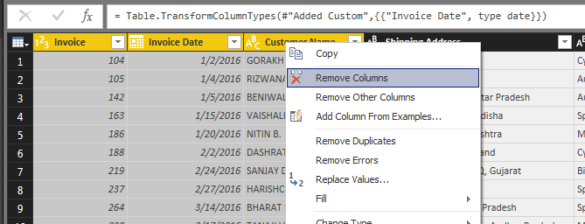
You can also remove columns from Manage Columns Section in Home Tab in Query Editor Ribbon.
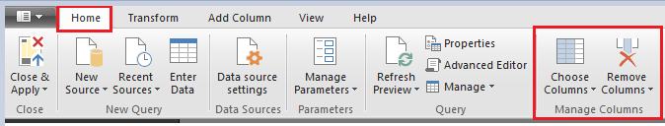
Name or Rename a Column
When you want give a meaningful name for a column that needs in Report, you can do it by renaming a column. To rename a column
Right click a column → Rename → Enter a meaningful Name
(OR)
Double click the column →that will allow you to edit Name → Enter a meaningful Name
Reorder Columns or Sort Columns in Power BI
One way is drag the required column and Drop at the position you want to place.
Second way, right-click on the column name that you want to move will open the context menu. Select the Move and then select Right, Left, To End, or To Beginning options.
Add Column / Add Custom Column
In Query Editor you can create custom formulas that operate on multiple columns in your table, and then place the results of such formulas into a new (custom) column. Query Editor makes it easy to create custom columns.
In Query Editor, select Custom Column from the Add Column tab on the ribbon.
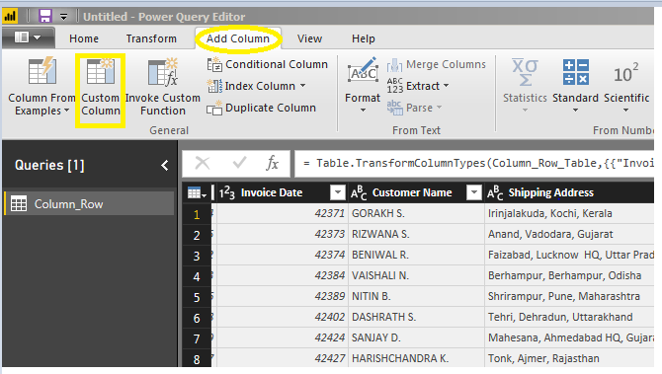
Once we select custom column a Custom Column window opens as below where we can provide New column name and Custom column formula.
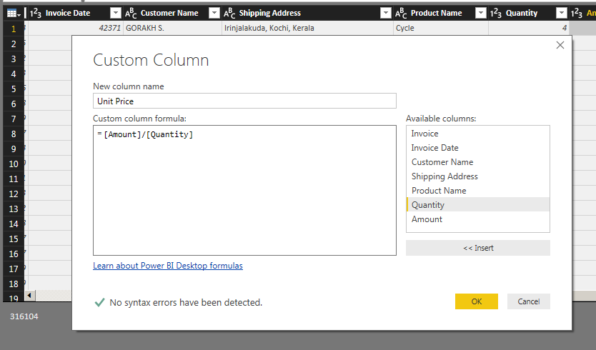
Split Columns
Sometimes you will get merged columns (one column with too much information). In that situation, you can use Power BI Split Columns option to split that column into multiple columns.
We have two options here to split columns as shown in below image.
- By Delimiter
- By Number of Characters
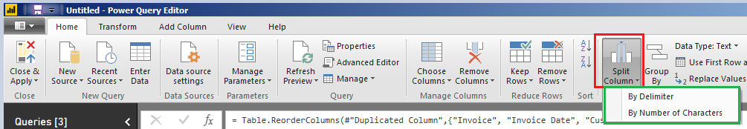

In order to split the columns in a table, right-click on the column that you want to split will open the context menu. Select the Split Columns and then select “By Delimiter” option.
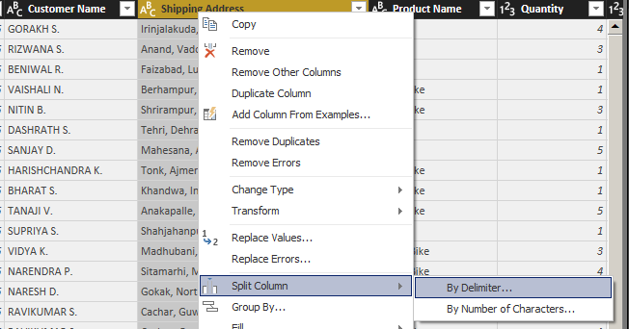
Selecting the “By Delimiter” option will open the following window.
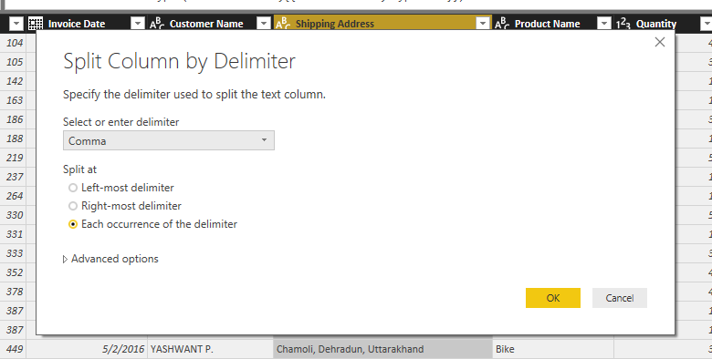
Select or enter delimiter
Please select the delimiter that you want to use as the split character from the drop down list. If it is not there in the list, then select Custom option in the drop down and specify that custom character.
Left most delimiter
This option will split the left most string before first delimiter.
Right most delimiter
This option will split right most string after the last delimiter.
Each Occurrence of the delimiter
Text will split at each occurrence of a delimiter.
Split Columns by Number of Characters
Right-click on the column that you want to split will open the context menu. Please select the Split Columns and then select “By Number of Characters” option.
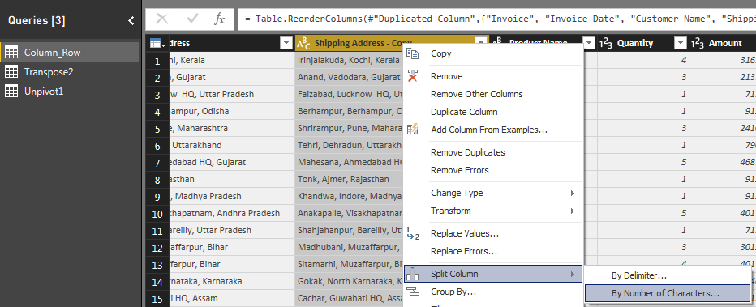
Selecting the “By Number of Characters” option will open the Split Column by Number of Characters window.
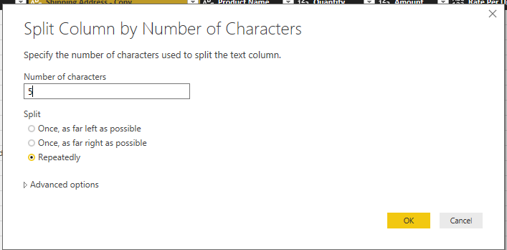
Number of Characters
Please specify the number of characters used to split the column. Let us give as 5.
Once, as far left as possible
This option will split the given string into two strings first string with first 5 Characters and second string with remaining characters.
Once, as far right as possible
This option will split the given string into two strings first string with all the characters except last 5 Characters and second string will be last 5 characters.
Repeatedly
Text will split for every 5 characters.

Merge Columns

With Power Query, you can merge two or more columns in your query. You can merge columns to replace them with a merged column, or create a new merged column alongside the columns that are merged.

Merge columns to replace existing columns

Select two or more columns that you need to merge. Press the CTRL key, and then click on the column headers to select each of the columns that you'll include in the merge.

NOTE: The order in which you select the columns sets the order of the values in the merged column.

Right-click the columns and click Merge Columns.

In the Merge Columns popup window, specify the separator that is in use between each of the column values. You can select from predefined separator values, or specify a custom separator value. Give a meaningful Name in “New column name” section.

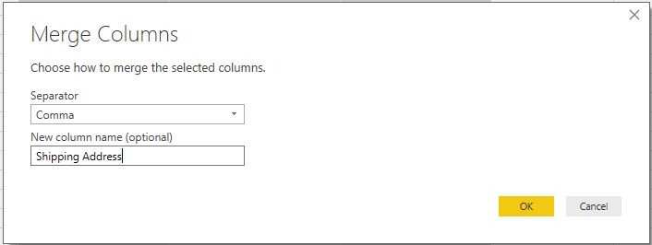

Click OK to create a merge column that replaces the columns selected for the merge operation.
Merge Columns to create a new column

Perform all the above steps in Add Column Tab in Query Ribbon to create a new column for all the merged columns.

PIVOT and UNPIVOT with Power BI

Turning columns to rows, or rows to columns is easy with Power Query and Power BI.

UNPIVOT → Converting Columns to Rows

PIVOT → Converting Rows to Columns

Transpose
This is used to reverse the rows and column of a table. Once you select the column and click on transpose option the rows becomes columns and column becomes rows. For using it click on Transpose option of Transform tab as below.
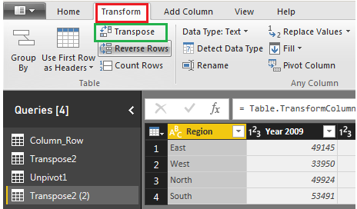

Region values are in Rows and Year Values are in columns in the below Query and we will use this for Transpose.

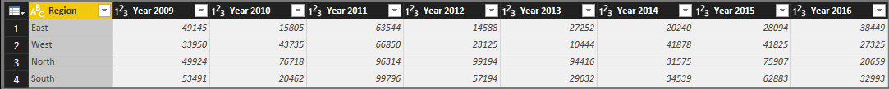

Once after Transpose the result will looks like below. Year values in rows and Region values in columns.

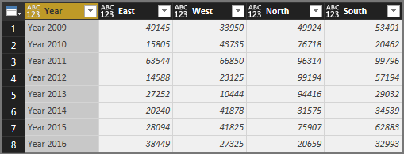

In built Row Transformations

- Header Row or Use First Row as Headers
- Keep Top Rows
- Keep Bottom Rows
- Keep Range of Rows
- Keep Duplicates
- Keep Errors
- Remove Top Rows
- Remove Bottom Rows
- Remove Alternative Rows
- Remove Duplicates
- Remove Blank Rows
- Remove Errors
- Group Rows

Use First Row as Header

When power bi is not able to identify headers automatically, you can manually do that using “Use First Row as Header”.

Reduce Rows
In case you want to filter the data you are importing, you have two options: either by keeping the specific rows or removing rows. Both options can be found by clicking Home → Reduce Rows.

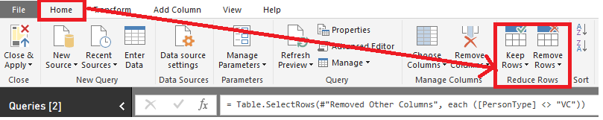

Under Keep Rows, you have the following options

Keep Top Rows → where you specify the number of top rows to keep.
Keep Bottom Rows → for which you pick the number of bottom rows to keep.
Keep Range of Rows → which skips a specified number of top rows and then keeps the chosen number of rows.

In addition to the first three options, which work on whole tables, you have Keep Duplicates and Keep Errors, both of which can work on either the whole table or the selected columns only. For example, if you select the whole table and choose Keep Duplicates, you will only see the rows that are complete duplicates of each other. However, if you choose only one column and click Keep Duplicates, you will get the rows where the values in the selected column are duplicates, regardless of other columns’ values.

Under Remove Rows, you have six options

Remove Top Rows → Removes a specified number of top rows. Works on the whole table only.
Remove Bottom Rows → Removes a specified number of bottom rows. Works on the whole table only.
Remove Alternate Rows → Removes rows following a user-supplied pattern: it starts with a specified row, then alternates between removing the selected number of rows and keeping the chosen number of rows. Works on the whole table only.
Remove Duplicates → Removes rows that are duplicates of other rows. Works on either the whole table or the selected columns only.
Remove Blank Rows → Removes rows that completely consist of either empty strings or nulls; if you need to remove blank values from one column, you can click on the arrow to the right of a column’s name and click Remove Empty. Remove Blank Rows Works on the whole table only.
Remove Errors → Removes rows that contain errors. Works on either the whole table or the selected columns only.

In case of Remove Duplicates and Remove Errors, there is a difference between applying these options to all selected columns or the whole table. In the first case, if you have new columns added to your query, the functions will not work on the new columns, because selecting all columns keeps their names in the code. To remove duplicates or errors from the whole table, select the table icon above row numbers and choose either Remove Duplicates or Remove Errors.

Group rows / Group By

In Query Editor, you can group the values in multiple rows into a single value. This can be useful when summarizing the number of products offered, the total sales, or the count of students or total salary paid for each department.

Let’s summarize our EMP table by Deptno and Job wise → TotSal, MinSal, MaxSal, AvgSal, CountOfEmp.

To do that, you can select Deptno and Job first, then click Home → Transform → Group By (Or) Transform → Table → Group By. The Group By window then opens; you’ll see a radio button to switch between Basic and Advanced settings. Specify one or more columns to group by and how to aggregate data. To group by more than one column, switch to Advanced settings, or you could have pre-selected multiple columns before clicking Group By.

